Gamification

Dr. Rana

Doha Ghaith

2180202

Table of Contents

ABSTRACT 1

Reliability 2

RESULTS AND DISCUSSION 3

# ABSTRACT

Gamification is a novel approach to increasing user engagement and motivation while also providing long-term experiences. It is a relatively new approach that has gained a lot of traction. It’s being used in a variety of fields. The goal of this article is to identify and map gamification trends and patterns. research. This article uses a systematic review in which document and content are examined.

Analyses were carried out. According to research, conceptual/descriptive papers outnumber other types of papers. Quantitative and qualitative papers, on the other hand, are becoming more popular. Education, teaching, and learning; engagement, motivation, and behavior change; and gamified designs are all emerging concepts, according to lexical analysis. The most commonly used keywords were gamification, engagement, and motivation, according to a keyword analysis. The majority of gamification articles are about education. The most beneficial lenses in gamification studies appeared to be Self-Determination Theory, Flow Theory, and the MDA (Mechanics, Dynamics, and Aesthetic) Framework.

Gamification is defined as “the use of game design elements in non-game contexts” (Deterding, Dixon, Khaled & Nacke, 2011, p.10). Another definition described it as “the process of game-thinking and game mechanics to engage users and solve problems” (Zichermann & Cunningham, 2011, p.xiv). There are many other aligned terms of gamification, such as productivity games, surveillance entertainment, funware, playful design, behavioral games, game layer, and applied gaming; however, gamification is the term that is widely accepted in related literature.

Despite its origins in marketing, it has since been applied to a wide range of fields, including education, health, business, and management. Gamification's main goal is to boost users' motivation to create more effective, efficient, engaging, long-lasting, and entertaining experiences. In other words, the primary goal of gamification is to keep users, or players, engaged in the game.

Focused Reviews on Theoretical/Conceptual Frameworks

Seaborn and Fels (2015) carried out a systematic deductive analysis of the concept of gamification, as well as a review of applied human participant research on computer-mediated gamification systems.

They presented the outlining theoretical/conceptual frameworks used in gamification research in their study. They went on to say that the main issue is a lack of adherence to the emerging standard definition of "gamification." Second, theoretical foundations are referenced and interpreted in a variety of ways.

Third, there is a gap between theory and practice – where theory is empirically untested and applied work lacks reference to theory – which limits the field's overall growth. Fourth, empirical studies using comparative and/or longitudinal designs are urgently needed to validate the impact of gamification features on participants' performance and enjoyment, as well as to identify best practices. While applied gamification research can be found in a variety of domains, the survey findings suggest that education is the most common, with the domains of health and wellness, online communities, crowdsourcing, and sustainability coming in second and third place, respectively.

# Reliability

The articles in the research corpus were coded according to predetermined categories in the first phase. In the second phase, another researcher recoded the same articles after completing the coding process. Following these phases, the results were compared, and any categories that differed from one another were re-examined. In the third phase, the categories that did not match were defined based on the examination, and these categories were only coded after the researchers reached an agreement. An independent researcher with experience in systematic reviews and gamification recoded research methodology, model and field categories, and calculated inter-rater reliability in the fourth phase.

The Study's Limitations, Strengths, and Importance

This study's findings are limited to articles published in peer-reviewed journals. These articles were chosen based on the above-mentioned inclusion criteria. The study's strengths, in addition to its limitations, are the large number of articles sampled. The previous study, which attempted to map research trends, looked at articles ranging in age from 18 to 120. However, this study used an open search to find 208 articles that met the inclusion criteria and thus provides a comprehensive picture of gamification research.

# RESULTS AND DISCUSSION

This section of the study examines gamification research trends (research method and model/design) as well as emerging patterns (lexical analysis, keyword analysis, related fields, most commonly used theoretical/conceptual frameworks, and citation analysis).

Research Methodology The schema proposed by Bozkurt, Akgun-Ozbek, and Zawacki-Richter (2017), which categorizes research methods as quantitative, qualitative, mixed, conceptual/theoretical/other, data mining and analytics, and practice based, was used in the research. The rationale to adopt this schema is that the schema covers new emerging methodological approaches as well as traditional ones. Accordingly, the mostly used research methodology is conceptual/descriptive type of articles (n= 97; 46.63%). Other methods that were mostly used are quantitative (n= 67; 32.21%), qualitative (n= 28; 13.46%), mixed (n= 7; 3.37%), data mining and analytics (n= 6; 2.88%), and practice-based (n= 3; 1.44%) (Figure 4). It was seen that as a novel idea, most of the gamification articles mostly adopted conceptual/ descriptive methodology. Though it is natural to see such a trend for an emerging field, the dominance of this type of methodology can undermine the gamification field, as it needs empirical findings to improve the field and fortify the pillars of gamification field. It is also noteworthy that the number of this type of articles stops increasing by 2014, while other type of methodologies had gained an increasing momentum by 2013. It was also seen that there is a significant increase in the number of quantitative and qualitative research from 2013 to 2016. Though few in number. it is also promising to see other type of methodologies such as mixed, data mining and analytics, and practice-based methodologies. Even though there is an absence of the conceptual/descriptive type of methodology in the following studies, the trend in qualitative, quantitative and mixed research accord with the findings of this research. Ortiz, Chiluiza and Valcke (2016) reported that, articles in their sampling (n= 30) used quantitative (n= 24; 80%) mixed (n= 4; 6.66%), and qualitative (n= 2; 13.33%) methodologies. In Hamari, Koivisto and Sarsa’s (2014) sampling (n= 24), quantitative (n= 17; 70.83%), mixed (n= 5; 20.83%), and qualitative (n= 2; 8.33%) approaches were identified as mostly used methodologies. Martí‐Parreño, Méndez‐Ibáñez and Alonso‐Arroyo (2016) also reported that 80% of the studies in their sampling (n= 139) used a quantitative approach while 13% used a qualitative approach and 7% a mixed-methods approach.

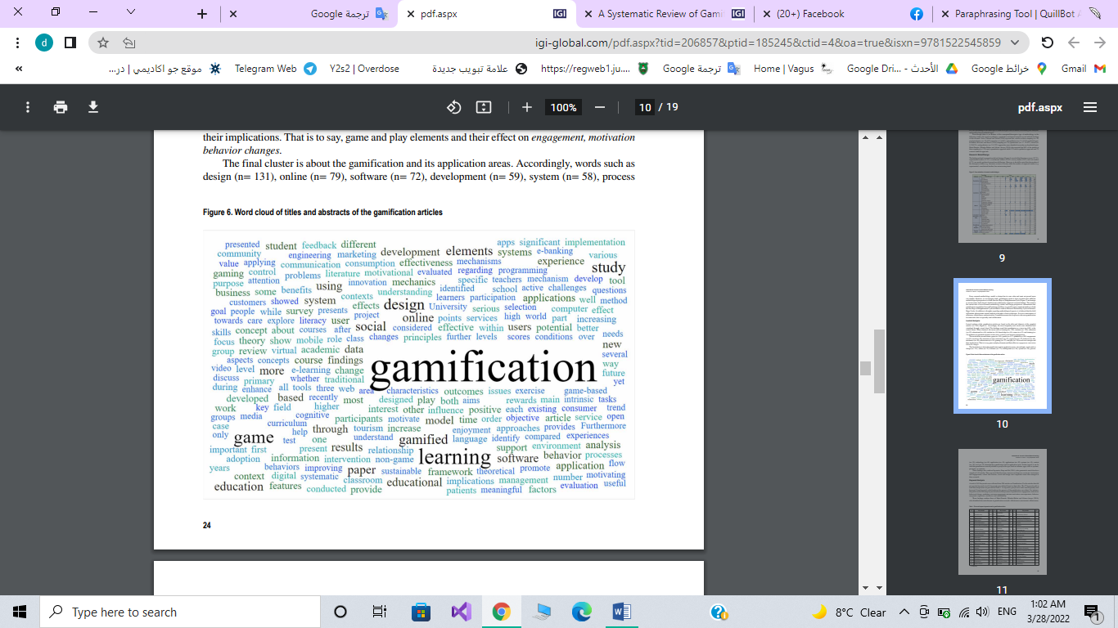

Figure :. Word cloud of titles and abstracts of the gamification articles

Keywords Gameful Design, Gamification, Gamified Learning, Research Trends, Systematic Review